PREMIUM November 8, 9, and 10 2019
ALL-BREED OBEDIENCE and RALLY TRIALS
(Rally Event 2019081530 and 2019081529)
(Obedience Events 2019081527 and 2019081528)
EVANSVILLE
OBEDIENCE CLUB, INC.
Evansville, Indiana
November 2019

At Evansville Obedience Club Training Center
1400A North Cullen Avenue, Evansville, IN 47715

THESE TRIALS ARE DEDICATED TO THE MEMORY OF LONGTIME EOC MEMBERS THAT PASSED IN 2019,
KARL ZIMMERMAN AND TERRY BLAKE.

Trial hours: November 8 2019 11:00 am to 5:30 pm CDT.
November 9 and 10 2019 7:30 am to 5:30 pm

Trials will be held indoors on cushioned flooring, unbenched.
Entries will be accepted until a full eight hours of judging has been reached for each obedience trial.
Entries are open to All-American dogs listed in the AKC Canine Partners program.

Entries close Wednesday October 23 2019 @ 6 PM CDT at the trial secretary's office for all trials, after which time entries cannot be accepted, cancelled, or altered except as may be specifically provided for in Chapter 11, Section 6 of the AKC Dog Show Rules.
CERTIFICATION
Permission has been granted by the AKC for holding these events under AKC rules and regulations.
James P. Crowley, Secretary
OFFICERS OF THE
EVANSVILLE OBEDIENCE CLUB, INC.

President Steve Stout
Vice President Debbie Purdy
Treasurer Danetta Ohning
Secretary Kathy Baumgart

OBEDIENCE TRIAL COMMITTEE:
Megan Wimsatt, Danetta Ohning, Cathi Blackburn, Debbie Yoder, Aaron Terwiske

Obedience Chair, Cathi Blackburn
13430 Middle Delaware Rd.
Henderson KY 42420
Cathi.blackburn@gmail.com 270-546-1083

Rally Chair, Danetta Ohning
509 Wessel Lane
Evansville, IN 47712
shamrockfriday@yahoo.com

Secretary, Megan Wimsatt
2012 Seasons Ridge Blvd.
Evansville, IN 47715
Mamilligan07@gmail.com 812-568-8868

JUDGE:
Mrs. Jean Nocilly #75179
PO Box 315 Cheswold, DE 19936-0315
Email: jnocilly@gmail.com
Phone: (315) 246-1813

November 8 Rally Obedience Trial 1 and Trial 2
Rally Novice A and B
Rally Advanced A and B | Rally Intermediate
Rally Excellent A and B | Rally Master
November 9 and 10 2019 OBEDIENCE
Beginner Novice A and B | Novice A and B
Open A and B | Utility A and B
Preferred Novice | Preferred Open
Preferred Utility
Graduate Novice | Graduate Open

CLASSES with jumps will run in random order for all obedience. Rally trials will run tall to short Trial 1 and short to tall Trial 2
PRIZES FOR THE TRIALS
Ribbon Prizes for Rally
Regular Classes:
First prize…...Blue
Second prize…Red
Third prize…..Yellow
Fourth prize….White
QUALIFYING SCORE…..A dark green qualifying ribbon
will be given to each dog attaining a qualifying score.
Highest Triple Q in Rally Advanced B, Excellent B and Master: Rosette
Rally Cone for New First Time RAE’S
RIBBON PRIZES FOR OBEDIENCE
Regular Classes:
First prize…...Blue
Second prize…Red
Third prize…..Yellow
Fourth prize….White
QUALIFYING SCORE…..A dark green qualifying ribbon
will be given to each dog attaining a qualifying score.
HIGHEST SCORING DOG IN REGULAR OBEDIENCE CLASSES:
Blue and Gold Rosette
HIGHEST COMBINED SCORE IN OBEDIENCE OPEN B AND UTILITY:
Blue and Green Rosette
OTCH: Red, White, and Blue rosette


Move-ups between trials will be allowed. The request to move up must be made to the Trial Secretary no later than one-half hour after the conclusion of classes.

ENTRY FEES

Weekend Special:
Any 4 entries same dog for obedience and/or rally.................$90.00
Single/Additional entry ……………………..............................$28.00

CATALOG
Catalog, pre-ordered...........................................................................$4.00
(A limited supply of catalogs will be available at the trial)

Mail entries with fees payable to “Evansville Obedience Club” to:

Megan Wimsatt
2012 Seasons Ridge Blvd.
Evansville, IN 47715

IMPORTANT NOTES:
Entries that are illegible or do not contain complete information, with the AGREEMENT form attached and including the jump height when applicable, will not be accepted. The exhibitor may not be notified of the entry’s status before closing.

The following pertains to all obedience events:
OBEDIENCE FEES include a 50-cent AKC Recording Fee and $3.00 Event
Service Fee... The fees are INCLUDED in the entry fee; DO NOT ADD FEES TO YOUR ENTRY. (American Kennel Club rule, Chapter 11, Section 2).
ENTRY FEES shall not be refunded in the event that a dog is absent, disqualified, excused by veterinarian or judge, or barred from competition by action of the show committee. If because of riots, civil disturbances, extreme and/or dangerous weather conditions, emergency, or other acts beyond the control of the management, it is impossible to open or complete the show, no refund of entry fees will be made.
PLEASE NOTE: Refund of entry fees, less AKC processing fees (see above) and a $5 administration fee, for bitches that come in season after the closing date of these trials, may be obtained by sending a veterinarian's certificate to the trial secretary. This certificate must be postmarked before the opening day of the trials or given to the trial secretary before the start of the trials.
RETURNED CHECKS do not constitute a valid entry fee. The trial secretary will collect a $25 administrative fee from the exhibitor for each returned check. Subsequent returned checks from the same exhibitor may result in cash only transactions.
ENTRIES will not be accepted if received without fees, signature, or AKC agreement on back of the official form. No fax, phone, or credit card entries accepted.
ENTRIES WILL NOT BE ACCEPTED if illegible or without complete information, including jump height. NO ENTRY that specifies any condition will be accepted. OWNERS without an e-mail address may not be notified of entry errors or other issues in time for corrections.
ALL RIBBONS/TROPHIES must be claimed at the trial. None will be mailed.
DOGS NEED be present only at scheduled time of judging and may leave immediately thereafter, unless required for further judging. THE HANDLER of each dog is solely responsible for having it ready at ringside when its class is to be judged. Judges are not required to wait for any dog.
ALL DOGS must be on leash and under control at all times. 'DOG' means either sex.
CRATING SPACE IS VERY LIMITED. NO EX-PENS or UNENTERED DOGS inside the building. EOC members’ crates may be available for use.
NO CRATING BEFORE THE ASSIGNED TIMES FOR YOUR CLASSES. CRATE IN VEHICLE IF POSSIBLE.
DUE TO LIMITED SPACE DOGS IN THE BUILDING MUST BE CRATED WHEN NOT IN THE RING SHOWING.
NO RV or OVERNIGHT PARKING.
EOC WILL PROVIDE SEATING.
THE EVANSVILLE OBEDIENCE CLUB, INC. assumes no responsibility for any loss, damage, or injury sustained by the exhibitors, handlers, or any of their dogs or property, and further assumes no responsibility for injury to children not under the control of their parents or guardians. Please see the back of the entry form for details. EOC participates in the AKC Arbitration option. Hotels and motels are considered part of the trial site.
*********This is a NON-SMOKING property*******
DONOT SUBMIT THIS PAGE WITH YOUR ENTRY FOR

MARK YOUR CALENDARS NOW!

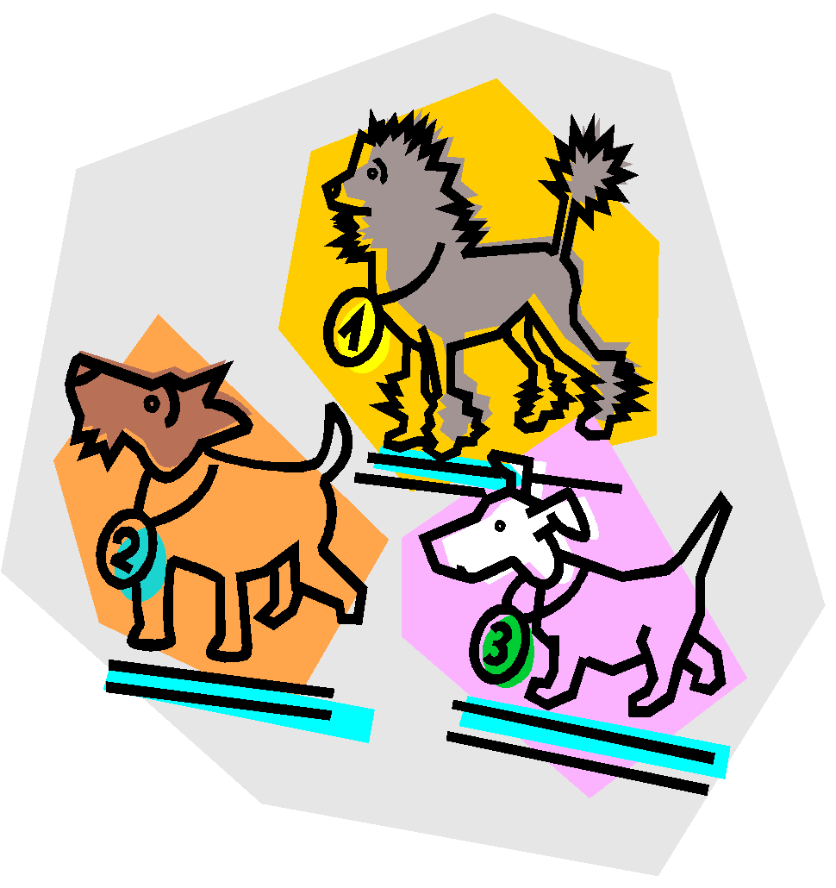
For the Evansville Obedience Club’s trials:
*2020 Trials

Check EOC or AKC websites for opening dates.

VETERINARIANS ON CALL
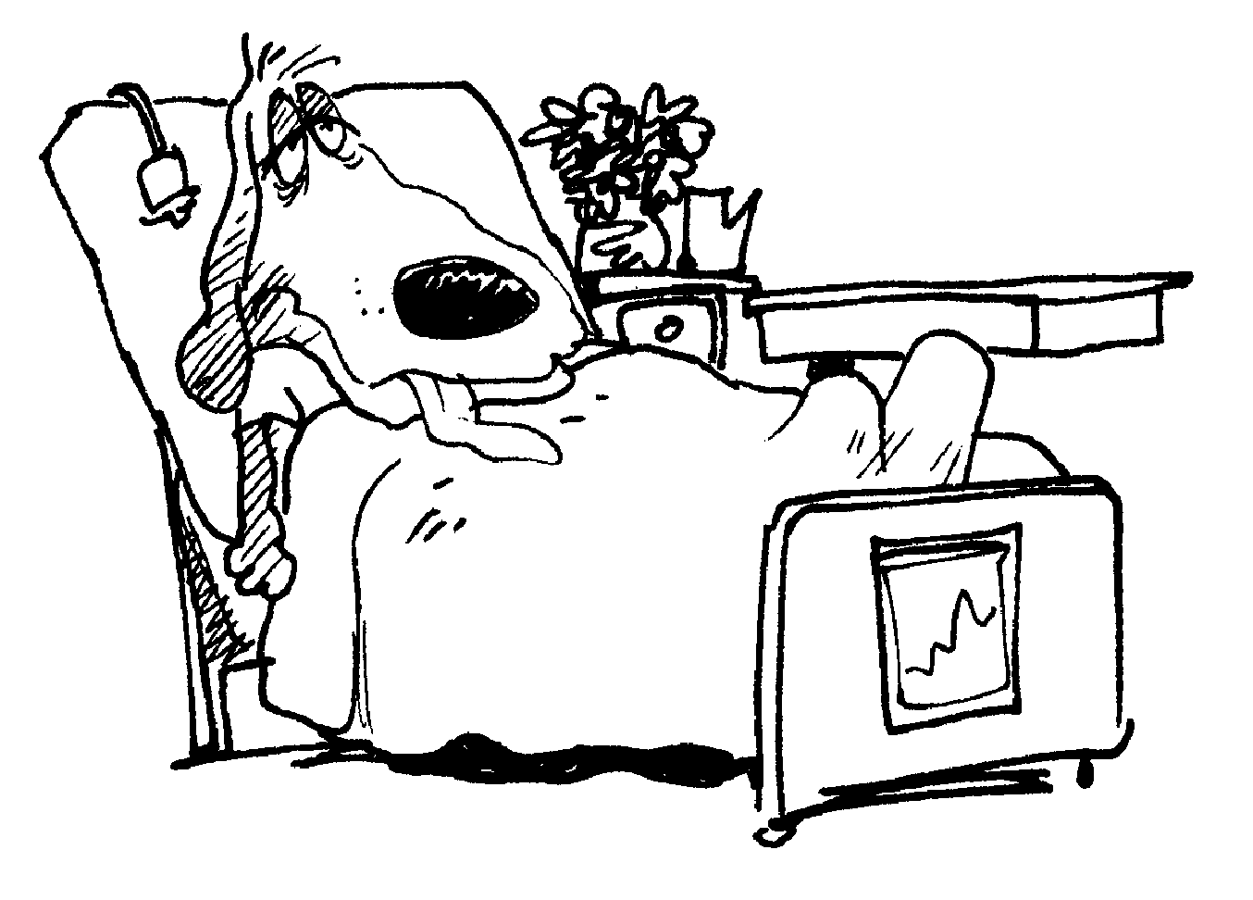
All Pet Emergency Clinic, 812/422-3300
104 S. Heidelbach Ave, Evansville
Friday-Saturday, 6 PM-8 AM
Saturday, 12 N through Monday, 8 AM

NOTICE TO EXHIBITORS .AKC Rules, Regulations, Policies and Guidelines are available on the American Kennel Club Web site, www.akc.org
AGREEMENTI (we) agree that the club holding this event has the right to refuse this entry for cause which
the club shall deem sufficient. In consideration of the acceptance of this entry and of the holding of this event and of the opportunity to have the dog judged and to win prizes, ribbons or trophies, I (we) agree to hold the AKC, the event-giving club, their members, directors, governors, officers, agents, superintendents or event secretary and the owner and/or lessor of the premises and any provider of services that are necessary to hold this event and any employees or volunteers of the afore-mentioned parties, and any AKC approved judge judging at this event, harmless from any claim or loss or injury which may be alleged to have been caused directly or indirectly to any person or thing by the act of this dog while in or about the event premises or grounds or near any entrance thereto, and I (we) personally assume all responsibility and liability for any such claim; and I (we) further agree to hold the aforementioned parties harmless from any claim for loss, injury or damage to this dog.
Additionally, I (we) hereby assume the sole responsibility for and agree to indemnify, defend and save the aforementioned parties harmless from any and all lose and expenses (including legal fees) by reason of the liability imposed by law upon any of the aforementioned parties for damage because of bodily injuries, including death at any time resulting therefrom, sustained by any person or persons, including myself (ourselves), or on account of damage to property, arising out of or in consequence of my (our) participation in this event, however such, injuries, death or property damage may be caused, and whether or not the same may have been caused or may be alleged to have been caused by the negligence of the aforementioned parties or any of their employees, agents, or any other persons. I (we) agree that any cause of action, controversy or claim arising out of or related to the entry, exhibition or attendance at the event between the AKC and the event-giving club (unless otherwise stated in its premium list) and myself (ourselves) or as to the construction, interpretation and effect of this agreement shall be settled by arbitration pursuant to the applicable rules of the American Arbitration Association. However, prior to arbitration all applicable AKC bylaws, rules, regulations and procedures must first be followed as set forth in the AKC charter and bylaws, rules, regulations, published policies and guidelines.
INSTRUCTIONS
- (Variety) if you are entering a dog of a breed in which there are varieties for show purposes, please designate the particular variety you are entering i.e., Cocker Spaniel (solid color black, ASCOB, parti-color). Beagles (not exceeding 13 inches over 13 inches but not exceeding 15 inches). Dachshunds (longhaired, smooth, wirehaired), Bull Terriers (colored, white), Manchester Terriers (standard, toy), Chihuahuas (smooth coat, long coat), English Toy Spaniels (King Charles and Ruby, Blenheim and Prince Charles), Poodles (toy, miniature, standard), Collies (rough, smooth).
- The following categories of dogs may be entered and shown in Best of Breed competition: Dogs that are Champions of Record and dogs which according to their owner’s records, have completed the requirements for a championship, but whose championships are unconfirmed. The showing of unconfirmed Champions in Best of Breed competition is limited to a period of 90 days from the date of the show where the dog completed the requirements for a championship.
- (Dog Show Class) Consult the classification in this premium list. If the dog show class in which you are entering your dog is divided, then, in addition to designating the class, specify the particular division of the class in which you are entering your dog, i.e., age division, color division, weight division.
- A dog must be entered in the name of the person who actually owned it at the time entries for a show closed. If a registered dog has been acquired by a new owner, it must be entered in the name of its new owner in any show for which entries closed after the date of acquirement, regardless of whether the new owner has received the registration certificate indicating that the dog is recorded in his name. State on entry form whether transfer application has been mailed to A.K.C. (for complete rule refer to Chapter 11, Section 3)

JUNIOR SHOWMANSHIP. If this entry is for Jr. Showmanship, please give the following information:
AKC Jr. Handler # Jr.’s date of birth
__ __ __ __ __ __ __ __ __ __ __ - __ __ - __ __
By signing I certify that the junior does not now and will not act as an agent/handler for pay while competing in Junior Showmanship
NAME OF JUNIOR HANDLER:
ADDRESS:
CITY: STATE: ZIP
If Jr. Handler is not the owner of the dog identified on the face of this form, what is the relationship of the Jr. Handler to the owner?: OFFICIAL AMERICAN KENNEL CLUB ENTRY FORM for all Events EVANSVILLE OBEDIENCE CLUB, INC.

Entry fees: Weekend Special: Any 4 entries same dog $90 (Multiple Specials may be purchased). Single/Additional entries $28 Fees payable to EOC. Mail entries to: EOC Trial Secretary: Deborah Yoder 1111 S Harlan Ave, Evansville, IN 47714.
Enclosed is $_______ for entry fees. Add $4.00 per catalog. TOTAL $_____
IMPORTANT: Please read the instructions on the reverse side carefully before filling out.
Rally Trial #1 November 8, 2019 Trial #2019081529
Rally Trial #2 November 8, 2019 Trial #2019081530

Saturday November 9, 2019 Trial #2019081527
Obedience Class | Additional Class(es)

Sunday November 10, 2019 Trial #2019081528
Obedience Class | Additional Class(es)

BREED  OF DOG |  | VARIETY (1) |  | SEX
FULL NAME
OF DOG

Enter number here  AKC REG. NO.  AKC LITTER NO.  ILP NO.  FOREIGN REG. NO. AND COUNTRY | BIRTH DATE  BIRTH PLACE (CIRCLE)  USA Canada Foreign  Do not print in catalog |  | 0BED JUMP  HGT  RALLY JUMP  HGT
BREEDER

SIRE

DAM

ACTUAL OWNER(S) [4]
(PLEASE PRINT)

OWNER’S ADDRESS

CITY STATE ZIP +4
NAME OF OWNER’S AGENT CODE #
(IF ANY) AT SHOW
Junior Handlers: complete and sign back of form.
I CERTIFY that I am the actual owner of the dog, or that I am the duly authorized agent of the actual owner whose name I have entered above. In consideration of the acceptance of this entry, I (we) agree to abide by the rules and regulations of the American Kennel Club in effect at the time of this show or obedience trial, and by any additional rules and regulations appearing in the premium list for this show or obedience trial or both, and further agree to be bound by the “Agreement” printed on the reverse side of this entry form. I (we) certify and represent that the dog entered is not a hazard to persons or other dogs. This entry is submitted for acceptance on the foregoing representation and agreement.
SIGNATURE of owner or agent duly authorized to make this entry:

Telephone: E-Mail:_________________________________

